**Flea market / Vendors welcome $10.00 set up fee**

**Contact: Heather Williams (309) 397-5984**

co

For more information visit www.rvaatractors.com

or call Rich Brewer (309) 620 -1527

Antique Tractor Pull Saturday 10 a.m.

Using former Hopedale Lions sled

Trophies awarded for 1st, 2nd & 3rd Place for each class

Hook fee: $20

|  |  |
| --- | --- |
| tractor show, parade | stationary engine show |
| tractor games  flea marketers  grill and ice cream truck | breakfast, lunch and cold drinks  silent Auctions, 50/50,  pedal tractor raffles  merchandise raffles |
|  |  |
|  |  |
|  |  |

Allis Chalmers

August 17-18, 2024

at Butler Haynes Park

9424 S. Mapleton Rd., Mapleton, IL 61547

40th Annual Old Fashioned

Tractor Show & Swap Meet

Featuring

Breakfast on grounds starting 8 a.m. Saturday. Golf carts, Gators and ATVs driven on show grounds must have certificate of insurance and driver must be >16 years of age.

Free parking: dry camping and trailer parking available free of charge.

No pets: Service dogs only. Grounds are handicapped accessible.

Show admission free--donations welcome

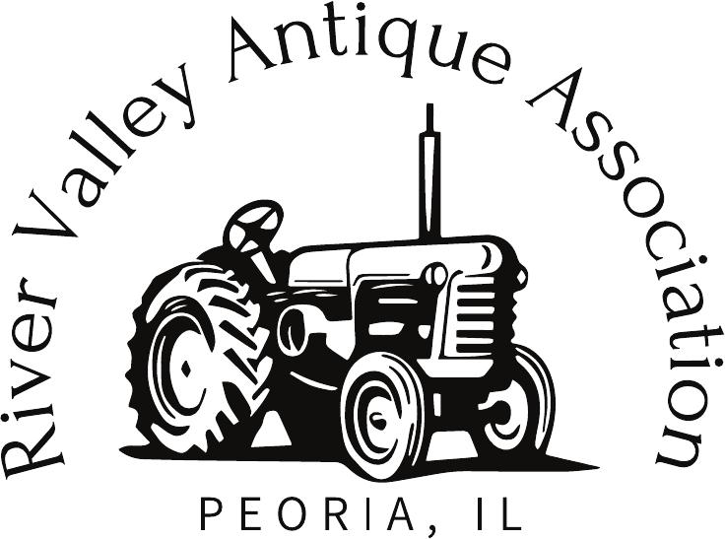

River Valley Antique Ass'n